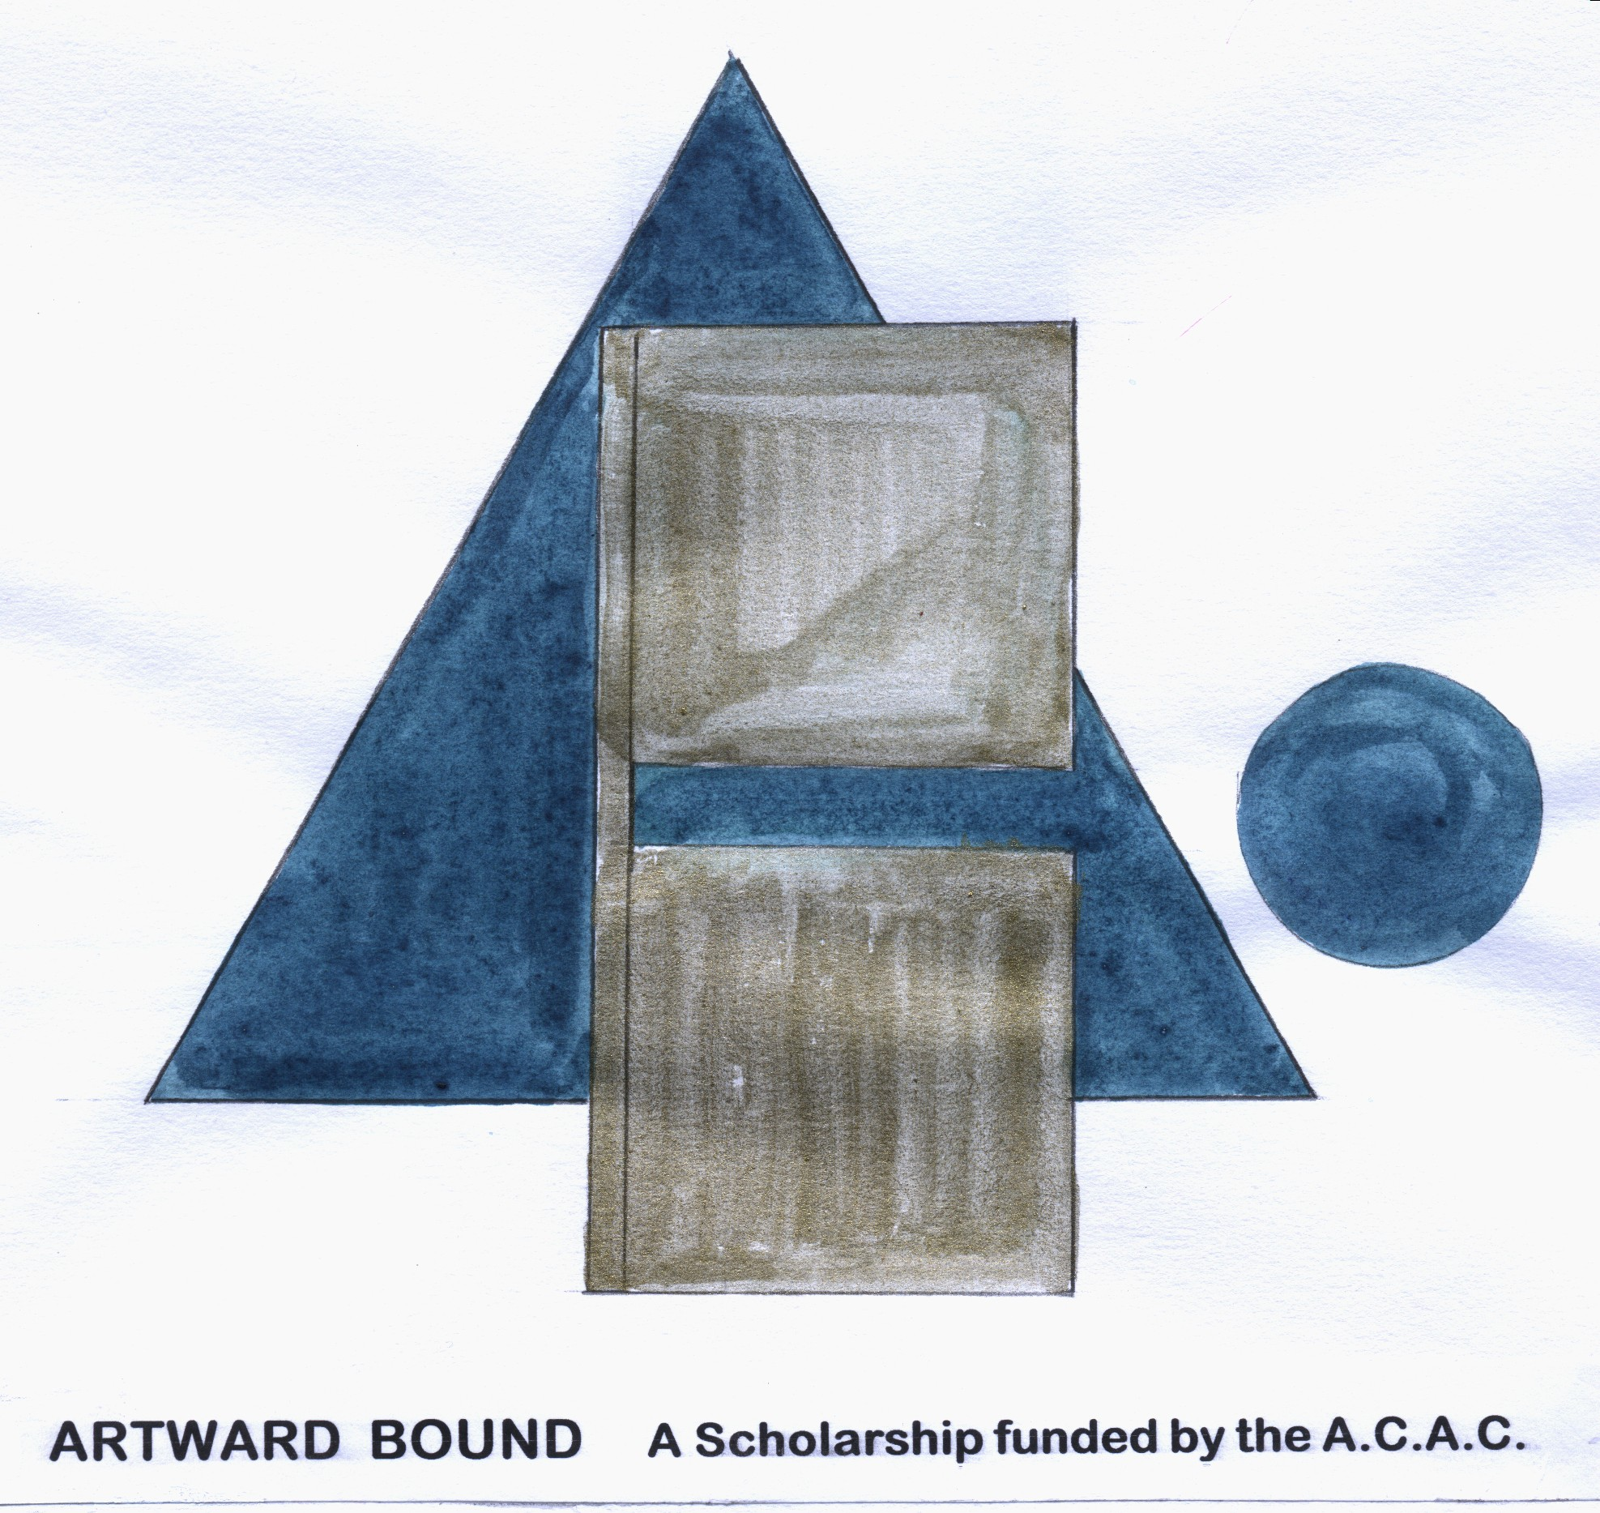
ALEXANDRA COMMUNITY ARTS COUNCIL
SCHOLARSHIP 2012

Local artists and craftspeople 18 years and over on the closing date of 31 October 2012 are invited to apply for The Alexandra Community Arts Council Scholarship to the value of
$2000

Overview

The Alexandra Community Arts Council offers artists from the Alexandra, Clyde, Omakau, Poolburn and the St Bathan’s area the opportunity to extend and challenge them, and to explore ways to enhance their skills and artisanship.

The Scholarship is funded from the biannual Art in the Garden event which was established in 2002

Examples of projects covered by this scholarship are
- Working as an artist in residence
- Attending workshops, schools and seminars
- Staging an exhibition
- Exploring of new materials and medium
- Working alongside a tutor
The project must be specifically outlined in the application.

Timeline

Applications for this scholarship are now called and will close on Wednesday October 31
Applications are confidential and will be returned to the applicant after the selection process is completed. All applicants will be notified of the panel’s decision. The panel’s decision will be final. The winners of both scholarships will be announced on Tuesday November 6
Completed applications should be sent to:

Kathi McLean
Secretary Alexandra Community Arts Council
C/Central Otago REAP
17a Brandon St
Alexandra
Returned by October 31 2011

ALEXANDRA COMMUNITY ARTS SCHOLARSHIP 2012
APPLICATION FORM

Full name: __________________________________________________

Address: ____________________________________________________

Telephone : ________________________________________________

Email: ______________________________________________________

Explain how and when you intend to use the $2000: Include a detailed budget of your anticipated expenses. Give a clear time frame of when the funds would be spent. (Extra pages may be included).
_____________________________________________________________________________________________________________________________________________________________________________________________________________________________________________________________________________________________________________________________________________________________________________________________________________________________________________________________________________________________________________________________________________________________________

Please attach a CV or portfolio or write a summary of your artistic pursuits. (Photographs, tapes or videos may be submitted as part of the application).
_____________________________________________________________________________________________________________________________________________________________________________________________________________________________________________________________________________________________________________________________________________________________________________________________________________________________________________________________________________________________________________________________________________________________________

Explain how receiving this scholarship will assist you in achieving your goals in this field.
_____________________________________________________________________________________________________________________________________________________________________________________________________________________________________________________________________________________________________________________________________________________________________________________________________________________________________________________________________________________________________________________________________________________________________

Please provide two written references with phone contact numbers. (We may contact your referees for further information to support your application).
________________________________________________________________________________________________________________________________________________________________________________________________________________________________________________________________________________________________________________________________________________________________________________________________________________________________________________________________________________________________________

Accountability: Within 6 months of completion of the project the artist will present a written report to the Alexandra Community Arts Council.

If practicable you will be invited to perform or exhibit in the Alexandra Community Council’s Art in the Garden biannual event.

Acknowledgement: Alexandra Community Arts Council will be acknowledged in any publicity about your project.

Signed: ___________________________________

Dated: ___________________________________

