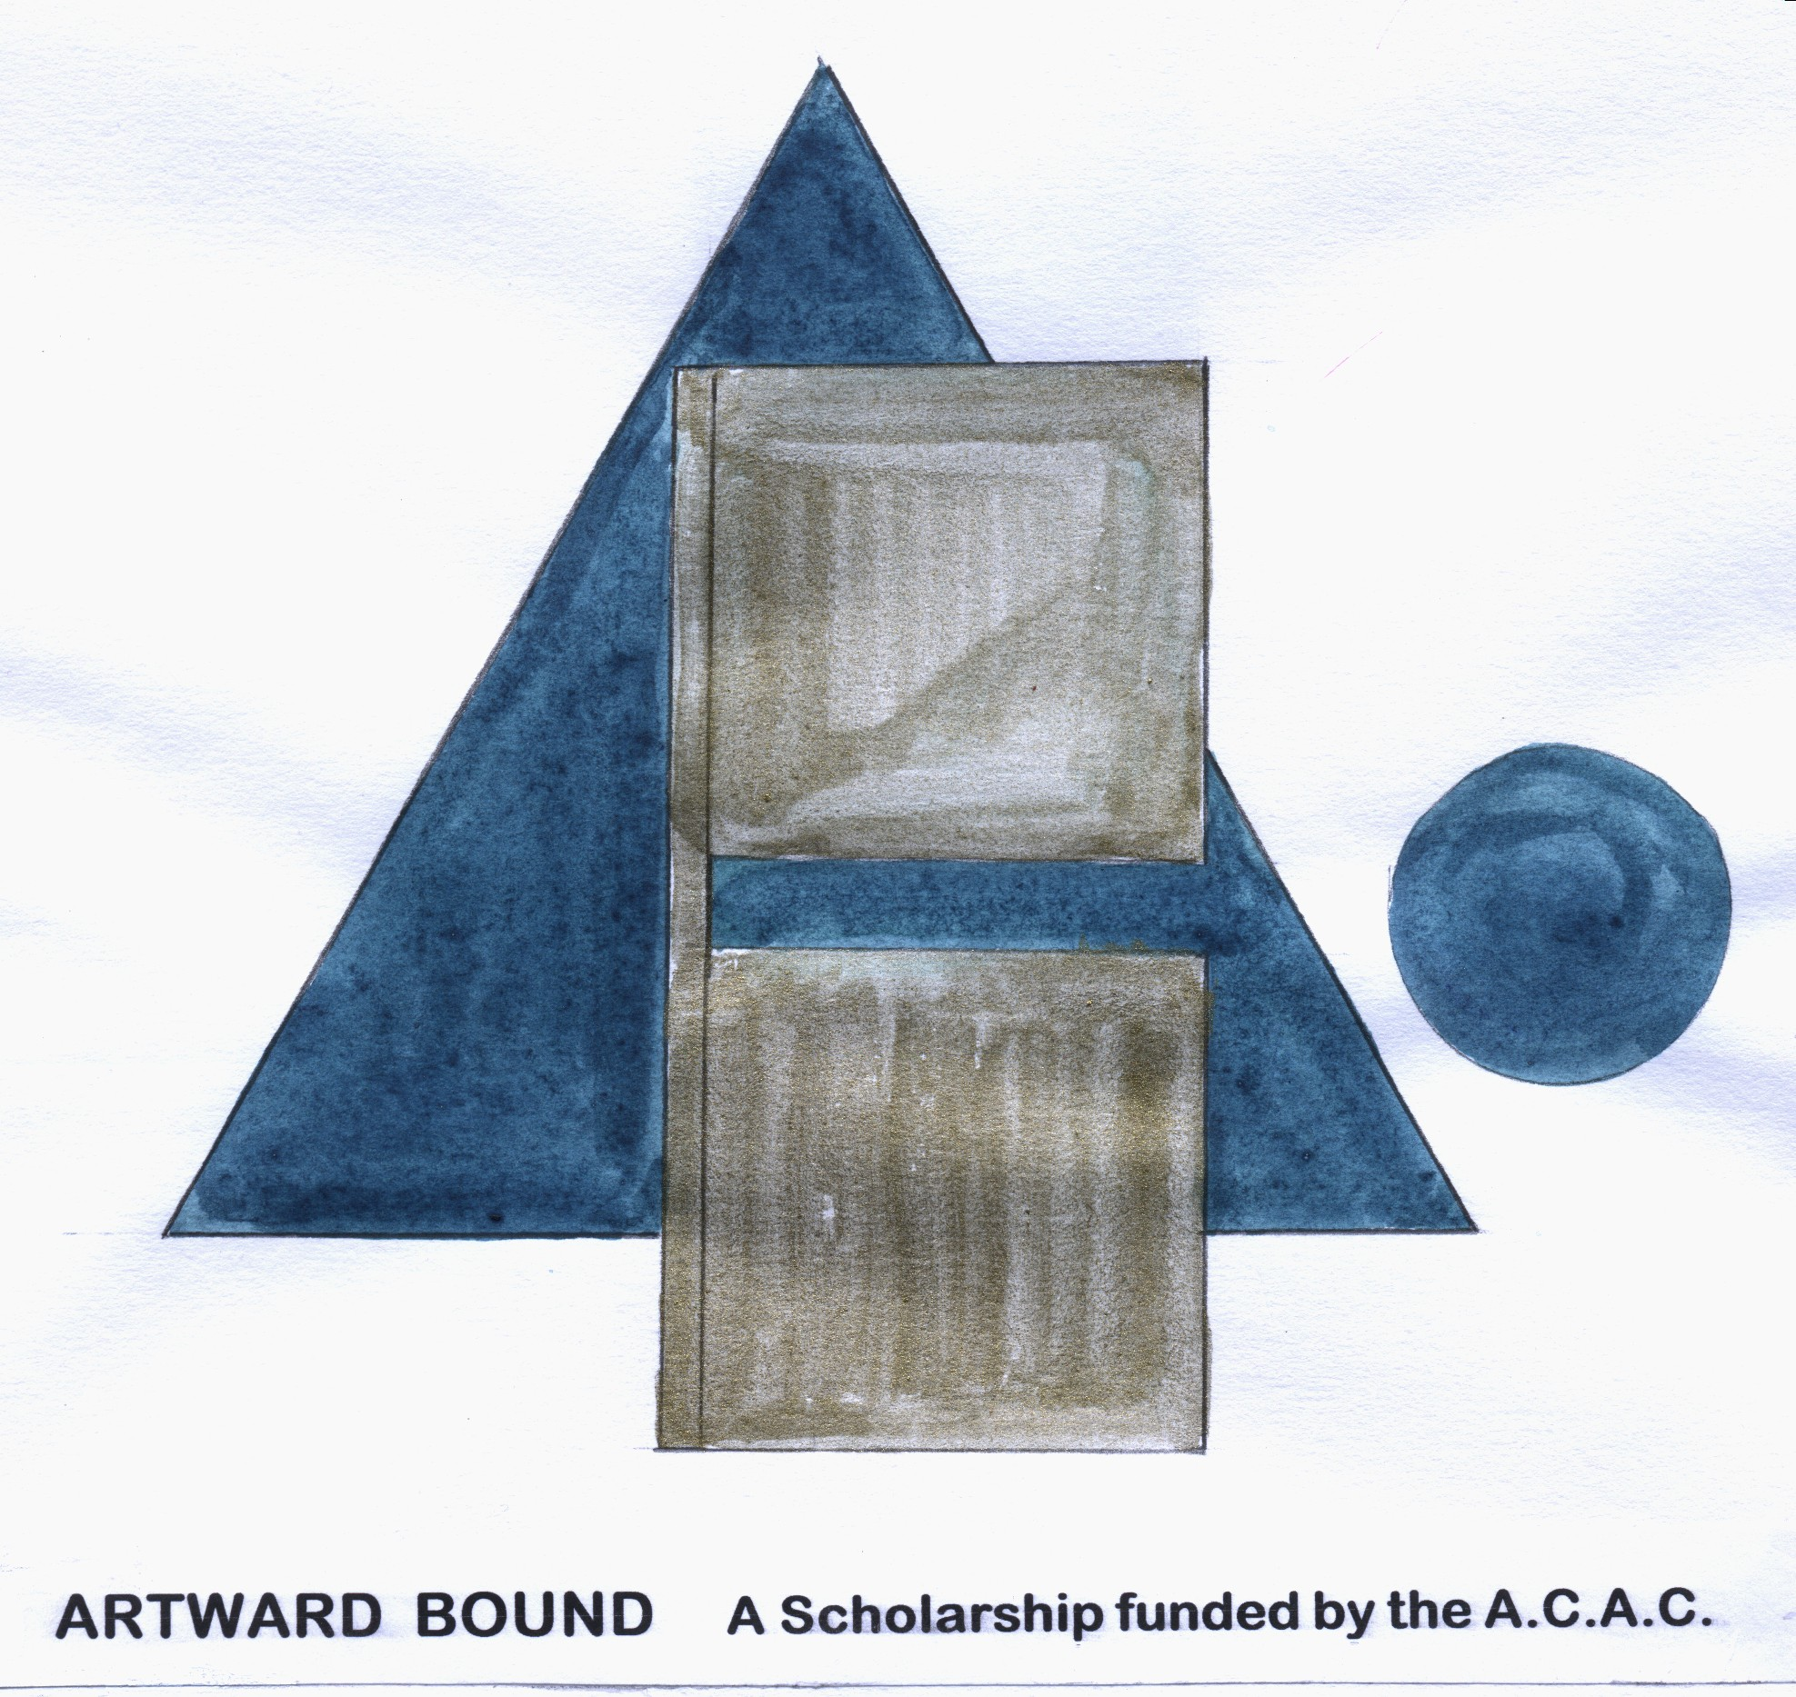
ALEXANDRA COMMUNITY ARTS COUNCIL
STUDENT SCHOLARSHIP 2012

Student artists and craftspeople under 18 years are invited to apply for The Alexandra Community Arts Council Scholarship of $1000.Closing date Wednesday October 31 5pm

Overview

The Alexandra Community Arts Council offers student artists from the Alexandra, Clyde, Omakau, Poolburn and the St Bathan’s area the opportunity to extend and challenge themselves, and to explore ways to enhance their skills and artisanship.

The award can be for any of the art disciplines of music, drama, dance and visual art.

The Scholarship is funded from the annual Art in the Garden event which was established in 2002.

Examples of projects covered by this scholarship are:
- Working as an artist in residence
- Attending workshops, schools and seminars
- Staging an exhibition
- Exploring of new materials and medium
- Working alongside a teacher or
The project must be specifically outlined in the application.

Timeline

Applications for this scholarship are now called and will close on Application forms are available from The Alexandra Library and Central Otago REAP. Applications are confidential and will be returned to the applicant after the selection process is completed.

All applicants will be notified of the panel’s decision. The panel’s decision will be final. The winners of the scholarship will be announced on Tuesday November 6 For more information phone Kathi at 448 6115 or email Kathi@coreap.org.nz

Completed applications should be sent to

Kathi McLean
Secretary Alexandra Community Arts Council
C/Central Otago REAP
17a Brandon St
Alexandra
No later than 5pm Wednesday October 31
ALEXANDRA COMMUNITY ARTS COUNCIL SCHOLARSHIP

2012 APPLICATION FORM

Full name: __________________________________________________

Address: ____________________________________________________

Telephone ________________________________________________

Email: ______________________________________________________

Explain how and when you intend to use the $1000: Include a detailed budget of your anticipated expenses. Give a clear time frame of when the funds would be spent. (Extra pages may be included).
_____________________________________________________________________________________________________________________________________________________________________________________________________________________________________________________________________________________________________________________________________________________________________________________________________________________________________________________________________________________________________________________________________________________________________

Please attach or write a summary of your artistic pursuits so far. (Photographs, tapes or videos may be submitted as part of the application).
___________________________________________________________________________________________________________________________________________________________________________________________________________________________________________________________________________________________________________________________________________________________________________________________________________________________________________________________________________________________________________________________________________________________________________________________________________________________________________________________________________________________________________________________________________________________________________________________________________________________________________________

Explain how receiving this scholarship will assist you in achieving your goals in this field.
_______________________________________________________________________________________________________________________________________________________________________________________________________________________________________________________________________________________________________________________________________________________________________________________________________________________________________________________________________________________________________________________________________________________________________________________________________________________________________________________________________________________________

Please provide two written references with phone contact numbers. (We may contact your referees for further information to support your application).
________________________________________________________________________________________________________________________________________________________________________________________________________________________________________________________________________________________________________________________________________________________________________________________________________________________________________________________________________________________________________

Accountability: Within 6 months of completion of the project the artist will present a written report to the Alexandra Community Arts Council.

If practicable you will be invited to perform or exhibit in the Alexandra Community Council’s Art in the Garden biannual event.

Acknowledgement: Alexandra Community Arts Council will be acknowledged in any publicity about your project.

Signed: ___________________________________

Dated: ___________________________________

